LSTM for time series

The below plot shows a portion of the raw data before it is passed into the model.

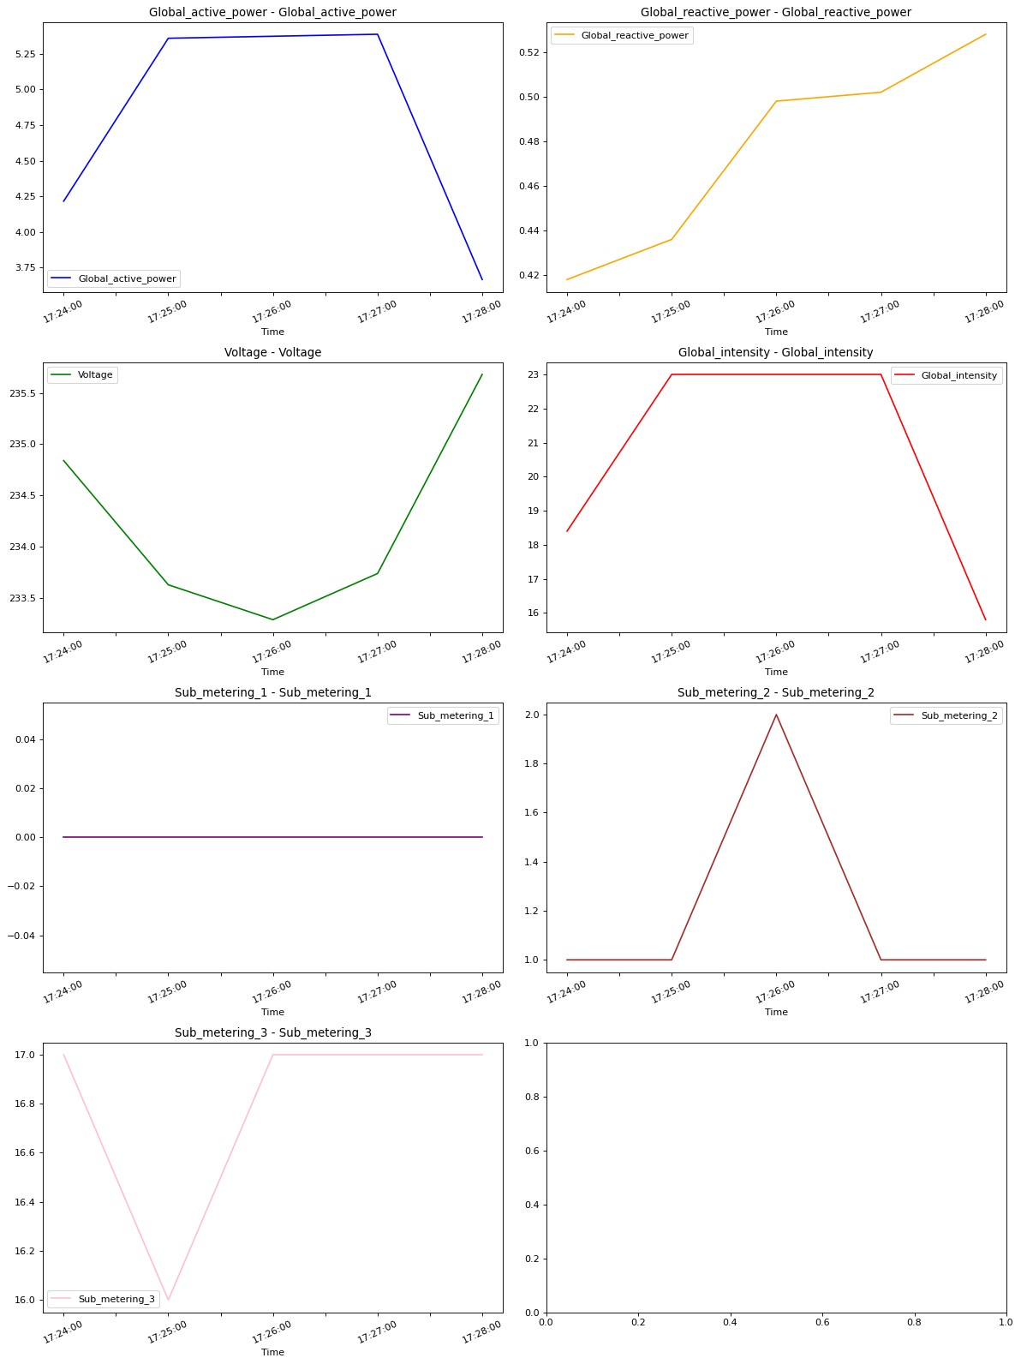

I have built a model using keras that will take the data inputs of the 7 features at t-1 and predict the Global_active_power value at t. As the dataset is very big it made the whole process a whole lot harder because I am not using the GPU. I had to struggle a bit in that. And I wanted to use the keras.layers.lstm to build the model as in the example of the time series in the keras page but it was not stated In the exercise how many steps in the past data we have to look for the prediction, it just said to use the data at time t-1 to predict for the data at t. so when I was building this model using the lstm layers, it kept bringing up error saying that the input shape should be of size 3 but it was getting input shape of size 2. So I just used normal sequential model with dense layers to build the model.

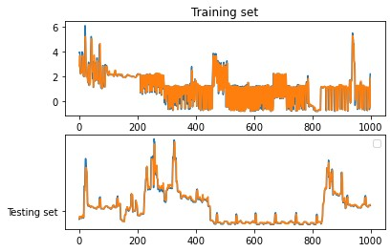

And this is what the plot of the prediction and the true values looks like.